

Summary for Mr Anthony Barnes
Thomas Redmond
TFAS Wealth Ltd
03 December 2025

Recommendation
Investment: £79,000 then £0 monthly

The agreed risk level considered your natural attitude to risk, capacity for loss and required return for your goal.
4
Agreed risk level^{[1]}
[1] As a Cautious Balanced investor you tend to see yourself as quite a cautious person and are inclined to view risk negatively rather than as a source of opportunity. If you have limited or moderate experience of investments and do not find financial matters particularly easy to understand then you may be suited to a Cautious Balanced approach to investing. You may also be suited to this approach if you take some time to make investment decisions and tend to be somewhat anxious about those decisions. As a Cautious Balanced investor you are inclined to look for safer investments, although you may consider taking some risk in exchange for increased potential returns.
Investments
0.41%
Weighted AMC^{[1]}

[1] Annual management charge – the annual fee charge by the fund management company to cover costs directly associated with managing your fund. This will not include all costs associated with the fund.
Investment | Provider | % Invested
Aviva Insured Funds Multi-asset Plus Fund II (GBP) | Aviva Life & Pensions UK Ltd | 100.00

Asset allocation

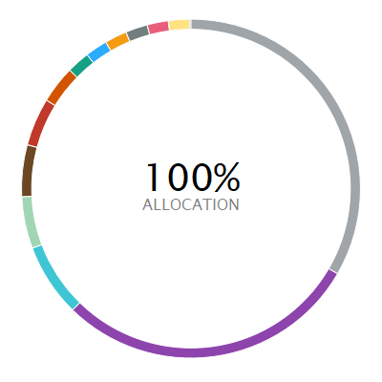 | ASSET ALLOCATION NET %⁽¹⁾ SHORT % LONG %  l Global (ex-UK) Fixed Income 33.43 -5.54 38.97  l North America Equity 28.95 0.00 28.95  l Europe (ex-UK) Equity 6.99 0.00 6.99  l Other 4.95 -64.73 69.68  l Absolute Return 4.94 0.00 4.94  l UK Corporate Bonds 4.58 0.00 4.58  l UK Government Bonds 3.58 0.00 3.58  l Japan Equity 2.18 0.00 2.18  l Cash - Short Term Money Market 2.13 -5.80 7.93  l Developed Pacific (ex-Japan) Equity 2.12 0.00 2.12  l Emerging Markets Equity 2.09 0.00 2.09  l Commodities 2.03 0.00 2.03  l UK Equity 2.02 0.00 2.02  l Global Property 0.02 0.00 0.02
⁽¹⁾ Due to rounding there may be a discrepancy between the Long/Short % and the Net %.

Investment performance
Individual cumulative investment performance graph
The chart shows an investment’s performance, calculated as NAV to NAV/Bid to Bid/Closing Price to Closing Price, with dividends/distributions reinvested, including the effect of ongoing costs and charges. These figures are calculated to the performance date 02 December 2025.
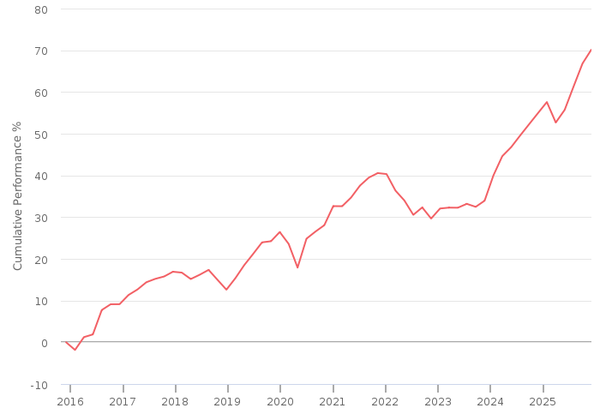
━━ | Aviva Insured Funds Multi-asset Plus Fund II (GBP)

Individual cumulative investment performance table
The table shows an investment’s performance, calculated as NAV to NAV/Bid to Bid/Closing Price to Closing Price, with dividends/distributions reinvested, including the effect of ongoing costs and charges. These figures are calculated to the month end performance date 31 October 2025.
FUND | 3M | 6M | 1YR | 3YR | 5YR | 10YR
Aviva Insured Funds Multi-asset Plus Fund II (GBP) | 5.58 | 12.61 | 11.92 | 33.59 | 36.21 | 70.66

Individual discrete investment performance table
The table shows an investments performance, calculated as NAV to NAV/Bid to Bid/Closing Price to Closing Price, with dividends / distributions reinvested, including the effect of ongoing costs and charges. These figures are calculated for calendar years and / or the period within the current year specified.
Fund | 2021 | 2022 | 2023 | 2024 | YTD
Aviva Insured Funds Multi-asset Plus Fund II | 6.91 | -8.73 | 8.13 | 10.02 | 11.01

Product

Name | Provider
Pension Portfolio - Choice | Aviva Life & Pensions UK Limited

Platform
Name | Provider
Aviva Platform | Aviva



Research Report for Mr Anthony Barnes
Thomas Redmond
TFAS Wealth Ltd
03 December 2025


Contents

Contents 2
Risk profile 4
How are risk levels used to create suitable investment portfolios? 4
Agreed risk level 5
Investments selection 6
Risk Rated investments 6
Portfolio details 6
Statistics 6
Investments 6
Risk level 7
Combined cumulative investment performance graph 8
Combined cumulative investment performance table 8
Individual cumulative investment performance graph 9
Individual cumulative investment performance table 9
Combined discrete investment performance graph 10
Combined discrete investment performance table 10
Individual discrete investment performance table 10
Combined top ten holdings 12
Asset allocation 13
Filters 14
Shortlist 14
Supplementary research 15
Data comparisons 16
Product selection 19
Selected Research Area 19
Recommended Product 19
Panel 20
Template 20
Filters 20
Shortlist 21
DNA features 22
Brochure comparisons 23
Platform selection 25
Recommended Platform 25
Panel 26
Template 26
Filters 26
Shortlist 27
DNA features 28
Brochure comparisons 29
Notes 32

In using this report you acknowledge that nothing in this report is, or shall be deemed to constitute, financial, investment or other advice or a recommendation or endorsement by Defaqto in respect of any product or service referred to herein. Your financial adviser, rather than Defaqto, will provide any such advice, recommendation or endorsement.

Risk profile
This section details how we reached an agreed risk level for this goal. It covers factors including your natural attitude to risk, capacity for loss and required return; factors used when selecting the types of investments and determining suitability.

How are risk levels used to create suitable investment portfolios?
The natural risk level, which is ascertained from the psychometric attitude to risk questionnaire score, is used as a starting point to discuss the actual level of risk you are willing and able to take to meet your specific investment objective.
In the discussion we had, you were shown a projection, based initially on your natural risk level, investment amount, target and desired time horizon. We then discussed this projection and altered any factor, including the risk level, until we agreed that the right balance had been achieved. This resulted in an agreed risk level for the investment.
To project the potential outcomes, each risk level is mapped to a collection of asset classes designed to expose you to an appropriate level of risk. Projections are produced by passing the asset class breakdown for the selected risk level to a stochastic engine that uses modelling provided by Hymans Robertson to project the future performance of the combination of asset classes.
By using these projections and discussions, we came to an agreed risk level for your specific investment objective. A portfolio will be built to meet your agreed risk level.
A summary of the results of this process is documented below.

Agreed risk level
Following an interactive discussion, and considering your natural attitude to risk, capacity for loss and required return for your goal, we agreed a risk level.
4  Cautious Balanced |  | As a Cautious Balanced investor you tend to see yourself as quite a cautious person and are inclined to view risk negatively rather than as a source of opportunity. If you have limited or moderate experience of investments and do not find financial matters particularly easy to understand then you may be suited to a Cautious Balanced approach to investing. You may also be suited to this approach if you take some time to make investment decisions and tend to be somewhat anxious about those decisions. As a Cautious Balanced investor you are inclined to look for safer investments, although you may consider taking some risk in exchange for increased potential returns.

client atr

Investments selection
Investment: £79,000 then £0 monthly
This section of the report details the issues identified as being important to the selection of investments and the other criteria used in selecting the most suitable investment.

Risk Rated investments

The risk rated funds selected were for the following mappings:
4  Cautious Balanced |  | A risk rated multi asset investment of level 4 targets a moderate level of capital appreciation by investing in a multi-asset portfolio. Investment will be mainly in UK fixed interest securities, equities, in particular UK equities, and property. A moderate amount of volatility should be expected.

Portfolio details

Statistics
0.41%
Weighted AMC^{[1]}

[1] Annual management charge – the annual fee charge by the fund management company to cover costs directly associated with managing your fund. This will not include all costs associated with the fund.

Investments
The client’s portfolio contains the following investments:

Investment | Provider | ISIN | Risk controlled  ^{[2]} | Diamond rating ^{[1]} | Family diamond rating ^{[1]} | % Invested
Aviva Insured Funds Multi-asset Plus Fund II (GBP) | Aviva Life & Pensions UK Ltd | GB00B8BV3X17 |  | N/A | N/A | 100.00
[1] Defaqto Diamond Rating
Diamond Ratings give managed funds an independent rating of 1 to 5 based on a detailed and well-structured scoring process allowing advisers and their clients to see where they sit in the market in terms of fund performance and competitiveness in other key areas such as cost, scale, access and manager longevity. 1 indicates the lowest rating across the characteristics and features while 5 is the highest.
Fund Diamond Ratings cover Multi Manager Funds across the 4 relevant IA sectors (Mixed 0-35%, Mixed 20-60%, Mixed 40-85% and Flexible), Directly invested funds across the 4 relevant IA sectors (Mixed 0-35%, Mixed 20-60%, Mixed 40-85% and Flexible) and Index Trackers.
Fund Family Diamond Ratings are split into Risk Targeted and Risk Focused ‘universes’, with the individual funds coming from the following IA sectors: Mixed 0-35%, Mixed 20-60%, Mixed 40-85%, Flexible, Specialist and Unclassified.
MPS Diamond Ratings are quantitative ratings to help identify the most consistent portfolios in terms of 1 year discrete risk adjusted returns, over the preceding 5 year period. Ratings of 1 to 5 correspond to a portfolio’s respective quintile within the portfolio’s Defaqto MPS Comparator peer group. For example, a rating of 5 represents the top 20% of portfolios that have experienced the most consistent risk adjusted returns, over the preceding 5 years discrete period, within the Defaqto MPS Comparator peer group.
[2] Risk Controlled
Risk controlled funds have been mandated to adhere to the Defaqto risk score it has been mapped against.

Risk level
The client’s agreed risk level is 4. The risk mapping of the new portfolio is 4 which matches the client’s agreed risk level.

Combined cumulative investment performance graph
The chart shows the combined investments performance, calculated as NAV to NAV/Bid to Bid/Closing Price to Closing Price, with dividends/distributions reinvested, including the effect of ongoing costs and charges. These figures are calculated to the performance date 02 December 2025.
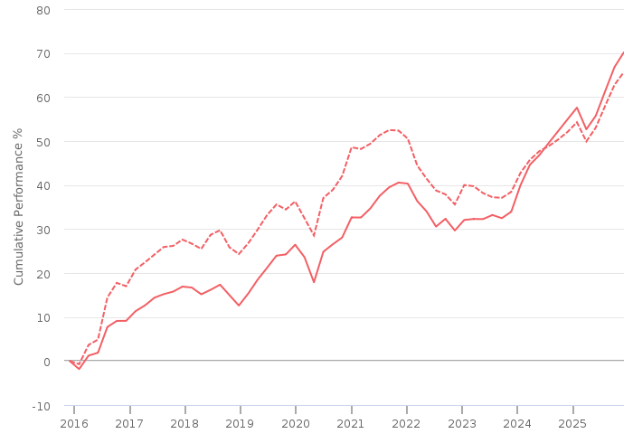
━━ | Combined | --- | Benchmark : Risk Level 4 Benchmark (GBP)

Combined cumulative investment performance table
The table shows the combined investments performance, calculated as NAV to NAV/Bid to Bid/Closing Price to Closing Price, with dividends/distributions reinvested, including the effect of ongoing costs and charges. These figures are calculated to the month end performance date 31 October 2025.
FUND | 3M | 6M | 1YR | 3YR | 5YR | 10YR
Combined Performance (GBP) | 5.58 | 12.61 | 11.92 | 33.59 | 36.21 | 70.66

Individual cumulative investment performance graph
The chart shows an investment’s performance, calculated as NAV to NAV/Bid to Bid/Closing Price to Closing Price, with dividends/distributions reinvested, including the effect of ongoing costs and charges. These figures are calculated to the performance date 02 December 2025.

━━ | Aviva Insured Funds Multi-asset Plus Fund II (GBP)

Individual cumulative investment performance table
The table shows an investment’s performance, calculated as NAV to NAV/Bid to Bid/Closing Price to Closing Price, with dividends/distributions reinvested, including the effect of ongoing costs and charges. These figures are calculated to the month end performance date 31 October 2025.
FUND | 3M | 6M | 1YR | 3YR | 5YR | 10YR
Aviva Insured Funds Multi-asset Plus Fund II (GBP) | 5.58 | 12.61 | 11.92 | 33.59 | 36.21 | 70.66

Combined discrete investment performance graph
The chart shows the combined investments performance, calculated as NAV to NAV/Bid to Bid/Closing Price to Closing Price, with dividends/distributions reinvested, including the effect of ongoing costs and charges. These figures are calculated for calendar years and/or the period within the current year specified.
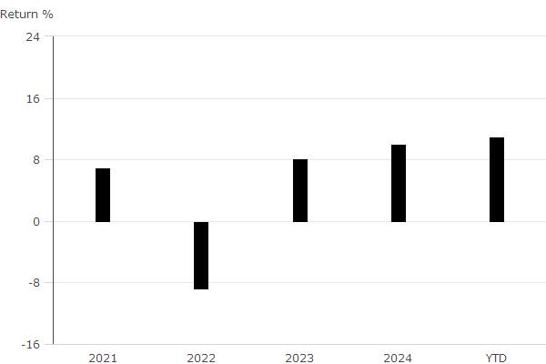

Combined discrete investment performance table

Fund | 2021 | 2022 | 2023 | 2024 | YTD
Combined Discrete Performance (GBP) | 6.91 | -8.73 | 8.13 | 10.02 | 11.01

Individual discrete investment performance table
The table shows an investments performance, calculated as NAV to NAV/Bid to Bid/Closing Price to Closing Price, with dividends / distributions reinvested, including the effect of ongoing costs and charges. These figures are calculated for calendar years and / or the period within the current year specified.
Fund | 2021 | 2022 | 2023 | 2024 | YTD
Aviva Insured Funds Multi-asset Plus Fund II | 6.91 | -8.73 | 8.13 | 10.02 | 11.01

Combined top ten holdings
The table shows the combined investments top ten holdings for the portfolio.
Name | Portfolio %
AI North Amer Eq Core FoF Acc | 22.87
Aviva Investors Global Sov Bd Zh GBP Acc | 12.53
Aviva Investors Multi-asset Core II D | 9.78
Aviva Investors Gl InvmGrdCorpBd Zyh£Acc | 6.13
Aviva Investors Stlg Lqudty 9 GBP Inc | 5.44
Aviva Investors Mlt-Strat Trgt Ret 5£Acc | 4.86
AI Europe Eq Ex UK Core FoF Acc | 4.41
United States Treasury Notes 1.875% | 4.21
AI Global Climate Credit Zh GBP | 4.08
Euro Schatz Future Dec 25 | -3.35

Asset allocation

 | ASSET ALLOCATION NET %⁽¹⁾ SHORT % LONG %  l Global (ex-UK) Fixed Income 33.43 -5.54 38.97  l North America Equity 28.95 0.00 28.95  l Europe (ex-UK) Equity 6.99 0.00 6.99  l Other 4.95 -64.73 69.68  l Absolute Return 4.94 0.00 4.94  l UK Corporate Bonds 4.58 0.00 4.58  l UK Government Bonds 3.58 0.00 3.58  l Japan Equity 2.18 0.00 2.18  l Cash - Short Term Money Market 2.13 -5.80 7.93  l Developed Pacific (ex-Japan) Equity 2.12 0.00 2.12  l Emerging Markets Equity 2.09 0.00 2.09  l Commodities 2.03 0.00 2.03  l UK Equity 2.02 0.00 2.02  l Global Property 0.02 0.00 0.02
⁽¹⁾ Due to rounding there may be a discrepancy between the Long/Short % and the Net %.

Filters
The following are the criteria applied to select the most suitable investments.

Investment(s) | Aviva Insured Funds Multi-asset Plus Fund II (GBP)
Panel | TFAS
Filter settings | Currency is GBP
Sort settings | None Applied

Shortlist
8 investments from a total of 8 risk level investments, as rated by Defaqto, matched the filters applied.
Investment | Provider | ISIN | Risk controlled | Diamond rating
Aviva Investors Multi-asset Plus Fund II Class 2 GBP Acc | Aviva Investors UK Fund Services Limited | GB00B7JRQQ84 |  | N/A
CT Sustainable Universal MAP Cautious C Acc | Columbia Threadneedle Fund Management Limited | GB00BKV44647 |  | N/A
CT Universal MAP Cautious Fund C Acc | Columbia Threadneedle Fund Management Limited | GB00BF99VY38 |  | N/A
HSBC Global Strategy Conservative Portfolio AC | HSBC Asset Management (Fund Services UK) Limited | GB00BYVXBK29 |  | N/A
Liontrust Sustainable Future Cautious Managed Fund Class 2 Net Income | Liontrust Fund Partners LLP | GB00BMN90304 |  | 
Vanguard LifeStrategy 40% Equity Fund A Acc | Vanguard Investments UK, Limited | GB00B3ZHN960 |  | 
Aviva Insured Funds Multi-asset Plus Fund II | Aviva Life & Pensions UK Ltd | GB00B8BV3X17 |  | N/A
Aviva/Liontrust Sustainable Future Cautious Managed S14 Pension | Aviva Life & Pensions UK Ltd | GB00BKKZPV01 |  | N/A

Supplementary research

Data comparisons

Data Compare 03/12/2025 11:07
 | Aviva Insured Funds Multi-asset Plus Fund II | CT Universal MAP Cautious Fund C Acc | HSBC Global Strategy Conservative Portfolio AC | Vanguard LifeStrategy 40% Equity Fund A Acc
ISIN | GB00B8BV3X17 | GB00BF99VY38 | GB00BYVXBK29 | GB00B3ZHN960
Defaqto Risk Rating | 4 | 4 | 4 | 4
Multi Asset | Yes | Yes | Yes | Yes
Stock Selection | Active | Active | Passive | Passive
5 Yr Cum. Return | 36.21% | 31.28% | 25.90% | 21.49%
10 Yr Cum. Return | 70.66% |  |  | 66.95%
5 Yr Volatility | 6.46 | 6.9 | 6.38 | 7.25
10 Yr Volatility | 6.76 |  |  | 6.55
AMC | 0.41% | 0.29% | 0.10% | 0.22%
Ongoing Charges |  | 0.29% | 0.21% | 0.22%

Data Compare 03/12/2025 11:09
 | Aviva Insured Funds Multi-asset Plus Fund II | CT Universal MAP Cautious Fund C Acc | HSBC Global Strategy Conservative Portfolio AC | Vanguard LifeStrategy 40% Equity Fund A Acc
ISIN | GB00B8BV3X17 | GB00BF99VY38 | GB00BYVXBK29 | GB00B3ZHN960
Defaqto Risk Rating | 4 | 4 | 4 | 4
Multi Asset | Yes | Yes | Yes | Yes
Stock Selection | Active | Active | Passive | Passive
5 Yr Cum. Return | 36.21% | 31.28% | 25.90% | 21.49%
10 Yr Cum. Return | 70.66% |  |  | 66.95%
5 Yr Volatility | 6.46 | 6.9 | 6.38 | 7.25
10 Yr Volatility | 6.76 |  |  | 6.55
AMC | 0.41% | 0.29% | 0.10% | 0.22%
Ongoing Charges |  | 0.29% | 0.21% | 0.22%

The funds data used within Defaqto Engage is sourced from Morningstar UK.
Morningstar UK Data Disclaimer
The data and calculations contained herein are: (i) proprietary to Morningstar; (ii) not warranted to be accurate, complete or timely; and (iii) provided to you by Defaqto Engage at your own risk. You agree that neither Morningstar nor Defaqto Engage is responsible for any damages or losses arising from any use of this information and that the information must not be relied upon by you, the user, without appropriate verification. Morningstar and Defaqto Engage inform you as follows: (i) no investment decision should be made in relation to any of the information provided other than on the advice of a professional financial adviser; (ii) past performance is no guarantee of future results; and (iii) the value and income derived from investments can go down as well as up.
Data and Calculations: © 2025 Morningstar UK. All Rights Reserved.

Product selection
This section details the issues identified as being important to the selection of a product and the other criteria used in selecting the most suitable product.

Selected Research Area
The selected research area is Personal Pension Plan

Recommended Product
No additional justification text has been entered
Product / Provider | Pension Portfolio - Choice  Aviva Life & Pensions UK Limited
Product type | Pension Portfolio - Choice
Profile | The Aviva brand name was launched in July 2002. The group was formed by the merger of CGU and Norwich Union in 2000. CGU came from the merger of Commercial Union and General Accident in 1998.  Aviva provide savings, retirement and insurance to 18 million (as at 31st December 2020) customers in their core markets (UK & Ireland Life, General Insurance: UK & Ireland, General Insurance: Canada).

Panel
The Whole of Market has been used in the product selection.

Template
No template has been used in the product selection.

Filters
The table below lists the filters applied and the feature value for the recommended product.
Feature | Filter | Recommended feature value
AKG Financial Strength | DNA 5 - A rating of 'A' denotes superior financial strength  DNA 4 - A rating of 'B+' denotes very strong financial strength | B+
Service Satisfaction Score (%) | DNA 5 - Very high satisfaction levels  DNA 4 - High satisfaction levels | 79
Online Valuations Access | DNA 5 - Online valuations available to both client and adviser | client,adviser
FAD (Flexi Access Drawdown) | DNA 5 - Flexi access drawdown facility available | Yes
Uncrystallised Funds Pension Lump Sum | DNA 5 - Uncrystallised Funds Pension Lump Sum facility available | Yes
Death Benefit Dependant | DNA 5 - Dependants receive both lump sum and drawdown upon the client's death | lump sum,drawdown
Death Benefit Nominee | DNA 5 - Nominees receive both lump sum and drawdown upon the client's death | lump sum,drawdown
Death Benefit Successor | DNA 5 - Successors receive both lump sum and drawdown upon the client's death | lump sum,drawdown

Shortlist
2 products from a total of 56 matched the filters applied.
Product name | Provider name | Total DNA for DNA features analysed
Pension Portfolio - Choice | Aviva Life & Pensions UK Limited | No DNA applied
Pension Portfolio - Core | Aviva Life & Pensions UK Limited | No DNA applied

DNA features
Quantitative benchmarking enabling detailed product feature analysis
Defaqto’s unique quantitative Data Numerical Analysis (DNA) helps you benchmark products based on the features they offer.
A value is applied to each feature within a product, helping you filter out products with features that are unsuitable for your client.
No Product DNA analysis was carried out.

Brochure comparisons
 | Pension Portfolio - Choice
 | Aviva Life & Pensions UK Limited
Financial strength rating provided by AKG | AKG Actuaries & Consultants Ltd, specialists in this field, have allocated a rating factor of A, B+, B, B-, C or D to each company dependent on its financial strength.  This company is rated B+.  A rating of 'A' denotes superior financial strength  A rating of 'B+' denotes very strong financial strength  A rating of 'B' denotes strong financial strength  A rating of 'B-' denotes effective financial strength  A rating of 'C' denotes challenged financial strength  A rating of 'D' denotes very challenged financial strength.  These ratings are the results of analysis of a range of key criteria, such as size, free assets, parentage, distribution image and reputation within the IFA market, expenses levels, market share and profitability.  AKG publish three financial strength report series or 'peer groups'. Each of these peer groups uses different criteria and weightings to arrive at a financial strength rating.  Rating Type Description  UK The UK rating rates life offices and non-life office SIPP providers. Defaqto displays these ratings across its life, pension and investment product tables.  Platform The platform rating rates operators offering platforms. It does not rate the product wrapper itself. Defaqto displays this rating on its platform table.  DFM The DFM rating rates the firms offering DFM solutions. It does not rate the solution itself. Defaqto displays this rating on its DFM table  Offshore The offshore rating rates providers offering offshore products. Defaqto displays this rating on its offshore investment product tables.  For more information on how the ratings are applied, please refer to the Engage user guide and FAQs.
Average Service Satisfaction Score | 79
Online Valuations Access  Client and/or adviser may access online valuations | client,adviser
Flexi access drawdown available  Flexi access drawdown facility available | FAD is available
Uncrystallised Funds Pension Lump Sum available  Uncrystallised Funds Pension Lump Sum facility available | An UFPLS style payment can be made via FAD. Please refer to FAD for details.
Death Benefit Dependant  Types of benefit payment facilitated for dependants upon the death of the client | lump sum,drawdown
Death Benefit Nominee  Types of benefit payment facilitated for nominees upon the death of the client | lump sum,drawdown
Death Benefit Successor  Types of benefit payment facilitated for successors upon the death of the client | lump sum,drawdown
Brochure Comparison 03/12/2025 11:33

Platform selection
This section details the issues identified as being important to the selection of a platform and the other criteria used in selecting the most suitable platform.

Recommended Platform
No additional justification text has been entered
Product / Provider | Aviva Platform  Aviva
Profile | Aviva is the largest insurance group in the UK is also a provider of life and pensions products to Europe.  The Aviva brand name was launched in July 2002. The group was formed by the merger of CGU and Norwich Union in 2000. CGU came from the merger of Commercial Union and General Accident in 1998.  Aviva provide savings, retirement and insurance.

Panel
The Whole of Market has been used in the platform selection.

Template
No template has been used in the product selection.

Filters
The table below lists the filters applied and the feature value for the recommended platform.
Feature | Filter | Recommended feature value
No filters were applied | No filters were applied | No filters were applied

Shortlist
1 products from a total of 57 matched the filters applied.
Product name | Provider name | Total DNA for DNA features analysed
Aviva Platform | Aviva | No DNA applied

DNA features
Quantitative benchmarking enabling detailed product feature analysis
Defaqto’s unique quantitative Data Numerical Analysis (DNA) helps you benchmark products based on the features they offer.
A value is applied to each feature within a product, helping you filter out products with features that are unsuitable for your client.
No Platform DNA analysis was carried out.

Brochure comparisons
 | Aviva Platform
 | Aviva
Platform Financial Strength Rating provided by AKG  Platform Financial strength rating provided by AKG | AKG Actuaries & Consultants Ltd, specialists in this field, have allocated a rating factor of A, B+, B, B-, C or D to each company dependent on its financial strength.  This company is rated A.  A rating of 'A' denotes superior financial strength  A rating of 'B+' denotes very strong financial strength  A rating of 'B' denotes strong financial strength  A rating of 'B-' denotes effective financial strength  A rating of 'C' denotes challenged financial strength  A rating of 'D' denotes very challenged financial strength.  These ratings are the results of analysis of a range of key criteria, such as size, free assets, parentage, distribution image and reputation within the IFA market, expenses levels, market share and profitability.  AKG publish three financial strength report series or 'peer groups'. Each of these peer groups uses different criteria and weightings to arrive at a financial strength rating.  Rating Type Description  UK The UK rating rates life offices and non-life office SIPP providers. Defaqto displays these ratings across its life, pension and investment product tables.  Platform The platform rating rates operators offering platforms. It does not rate the product wrapper itself. Defaqto displays this rating on its platform table.  DFM The DFM rating rates the firms offering DFM solutions. It does not rate the solution itself. Defaqto displays this rating on its DFM table  Offshore The offshore rating rates providers offering offshore products. Defaqto displays this rating on its offshore investment product tables.  For more information on how the ratings are applied, please refer to the Engage user guide and FAQs.
Weighted Satisfaction Scores  This is the weighted satisfaction score achieved in the IFA Platform Star Rating survey | 81
General Investment Account  A general investment account facility, where the underlying investments are not product wrapped. | A general investment account is available via the, 'Investment Portfolio'. The minimum investments are £50 per month or a single investment of £1,000.
ISA available  ISAs available | The ISA Portfolio is a Stocks & Shares ISA provided by Aviva.
Personal Pension Plan or Self Invested Personal Pension Available  Personal pension product (PPP or SIPP) available on the platform | Yes.
Online Client Valuations Available  Platform provides clients valuations online | Online client valuations are available.
Platform Access - Adviser  Adviser can have platform access | Advisory firms can set different levels of online access at Corporate, Registered Individual, Principal, Administrator and Adviser levels.  Aviva believes that individual firms should have the freedom to set their own access for the different levels within their organization. With this in mind the Aviva Platform allows the advisory firm to configure the access levels to meet its own requirements.  The Aviva Platform offers the following functionality:  Pre-sale online tools and analysers:  - Fund research: allowing a detailed view of all of the funds on the platform, their performance and third party fund ratings  - Fund charting: allowing the comparison of the performance of funds, sectors and indices  - Fund documentation: including fund factsheets, reports and accounts and simplified prospectus documents  - Illustrations: a regulatory requirement for all portfolios  - Investment profiles: allowing easy and efficient creation and management of a range of model portfolios.  Post-sale tools and analysers:  - Current valuations: of portfolios online  - Rebalancing: to re-instate the asset allocation on a range of frequencies  - Bulk trading and bulk rebalancing: allowing efficient management of groups of clients  - Detailed performance data: showing how investments have performed for specified time periods  - Detailed fund data: breaking down portfolio information to individual fund level  - Transaction information: showing all client portfolio transactions  - Illustrations: for accumulation, income drawdown and estimated maturity values  - Lifetime allowance usage: a report showing post-retirement client lifetime allowance usage in the current year  - Summary view of issued warnings: a report detailing the income warnings issued for clients  - Available taxable income: a report showing clients available taxable income in the current year  - Capital Gains calculator  - Client review date: a report showing the next Government Actuaries Department income review date for post-retirement clients in Capped Drawdown  - Client reporting: a report based on portfolios, valuations or transaction history.  Client Access:  - Clients can view valuations of their product portfolios and keep track of their investments.  - Clients can also access electronic copies of correspondence that has been sent to them online.  - Clients do not have any online trading capability and all trades must be placed via their financial adviser.  - Clients cannot perform online transactions directly.
Platform Access - Client  Client can have platform access | Clients can view correspondence relating to their portfolio and advisers can see correspondence for their platform clients. Clients are able to view valuations of their product portfolio and keep track of their investments online.
Automatic Withdrawals  Facility to set up fixed (percentage or amount) regular withdrawals, other than pension related income drawdown facilities | Where permitted, clients may withdraw some or all of any cash balance in the ISA and Investment Portfolios at any time by sending Aviva a signed written instruction to do so.  Clients can also opt for regular withdrawals by completing the relevant application. They can choose the frequency and dates which they want to receive the withdrawals.  The minimum amount that can be withdrawn as a lump sum is £500, or £50 for regular withdrawals. The remaining balance in any product Portfolio after any withdrawal must be at least £250.  Fund-specific withdrawals are also available. At least £50 must be left in any fund.  Advisers are able to create their own withdrawal preferences and actively choose and manage how specific funds are disinvested to pay for withdrawals.
Brochure Comparison 03/12/2025 11:34

Notes
KEY: na = not applicable, ns = not stated, nd = not disclosed
The Data Numerical Analysis (DNA) allows the analysis of data on both a quantitative and a qualitative basis, showing not only who does what, but more importantly, how well they do it. This is achieved by a system of benchmarking or ranking on a 1 to 5 basis called DNA. A score of 1 indicates a weak feature; a score of 5 indicates an excellent feature.

